Join us November 3-6, 2011 on a journey to rejuvenation at Miraval Arizona Resort & Spa!

Reset your mind, body and lifestyle to a healthy rhythm at this celebrated resort. You’ll be inspired in the warmth of the Tucson desert while you enjoy relaxation, pampering, fitness, and focus on your wellness.

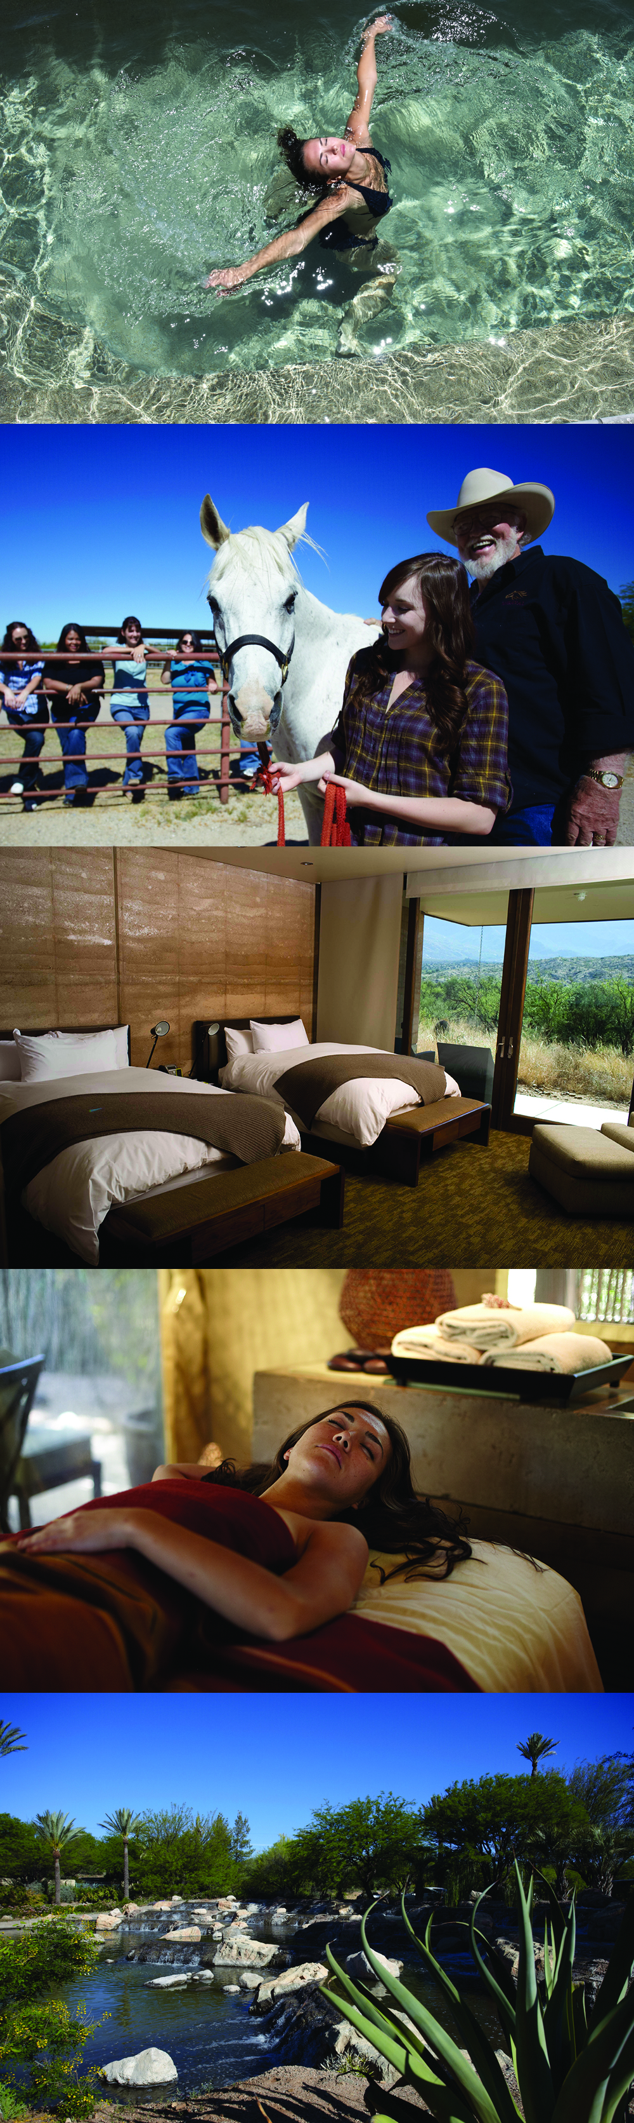
Our Preliminary Itinerary:
Thursday, November 3
Afternoon Arrivals at Tucson Airport, transfers to Miraval Resort
(Airfare not included, Alaska Airlines has non-stop SEA-TUC flights)
Greeting and check-in at Miraval Resort
Spa appointments, classes or other activity
6:30 Welcome cocktail party (hosted by Stellar Travel)
7:30 Dinner reservations in Cactus Flower restaurant
Friday, November 4
Morning stretch class, morning hike or other early activity
Breakfast
9:00 Optional Golf at Stone Canyon (club rentals additional)
Spa appointments, classes, activities, pool time, relaxation
Lunch
Activities, classes
Dinner in Cactus Flower restaurant
Saturday, November 5
Morning classes, hike, other optional activities
Breakfast
Spa appointments, classes, activities
Lunch
Activities, classes
Farewell Cocktail party and appetizers
Dinner in the restaurant
Sunday November 6
Morning activities
Breakfast
Transfer to Tucson airport
Box lunch for travel is included (Optional extended stay available)

Explore www.stellartravel.com/vacation/miraval for more information or
contact Susan Bluhm, susan@stellartravel.com 425.586.4518 for your reservation.
Treat yourself to our girls getaway weekend and return refreshed and renewed!

$1,350 + taxes and resort fee per person (shared) $450 per night per person + taxes/fees group rate.
$1,545 + taxes and resort fee per person (single) $515 per night per person + taxes/fees group rate.
Extending your stay pre-or-post is available at the special Stellar Travel group rates of $450 per day + fees/taxes, all inclusive, share accommodation or $515 single accommodation.
Miraval is a non-tipping resort for ultimate relaxation. Group rate based on minimum of 11 participating women as of 9/4/2011. Airfare is not included. Deposit of first and last night accommodation required at time of reservation. Deposit is transferable to a future stay if cancellation received 10 days prior to arrival. Cancellations within 10 days of arrival will forfeit deposit. Participants may extend their stay up to 3 nights pre/post group dates for the same discounted group rate when reserved in advance. Golf at Stone Canyon is included when daily $130 credit applied.

